**Historical Data of 3 different Supermarket (A, B and C)**

We have 3 different Supermarket. A, B and C.

First, checked the rating of each supermarket.

Supermarket C has the highest rating among all the others which is 7.07 but, this is very close to the rating of Supermarket A which is 7.02.

Now, let’s talk about gross income of each supermarket.

Supermarket C has the highest gross income of 5265.2 and B has the lowest income of 5057.0 same as A.

* The Supermarket A is in “Yangon” city.
* The Supermarket B is in “Naypyitaw” city.
* The Supermarket C is in “Mandalay” city.

**Male vs Female**

**Female:**

Supermarket C has more female customers (2937.4) than others.

Supermarket A has 2536.6 female customers.

Supermarket A has 2520.4 female customers.

**Male:**

Supermarket B has more male customers (2536.6) than others.

Supermarket A has 2520.5 female customers.

Supermarket A has 2327.8 female customers.

From this, we can conclude that the more female customers, the more gross income will be generated.

Checked the unit price of each product line for all the stores.

Sum of Unit Price. How much income a store is getting from the a single product line.

Highest income of Store A comes from “Home and Lifestyle” and lowest comes from Health and beauty which are 3630 and 2344 respectively.

Highest income of Store B comes from “Home and Lifestyle” and lowest comes from Health and beauty which are 3700 and 2742 respectively.

Highest income of Store C comes from “Home and Lifestyle” and lowest comes from Health and beauty which are 3883 and 2445 respectively.

Checking date vise income of each store: Total = Unit price * quantity + tax (5%)

**January Month**

Store-A)

Total Income: 38,681

Highest is Home and Lifestyle

Lowest is Health and beauty

Store-B)

Total Income: 37,176

Highest is Sports and Travel

Lowest is Home and Lifestyle

Store-C)

Total Income: 40,435

Highest is Sports and Travel

Lowest is Home and Lifestyle

Total Income of January month is 116,292. C>A>B

**February Month:**

Store-A)

Total Income: 29,860

Highest is Food and Beverages

Lowest is Health and beauty

Store-B)

Total Income: 34,424

Highest is electronic accessories

Lowest is Home and lifestyle

Store-C)

Total Income: 32,935

Highest is Fashion accessories

Lowest is Home and lifestyle

Total Income of February month is 97,219.

**March Month:**

Store-A)

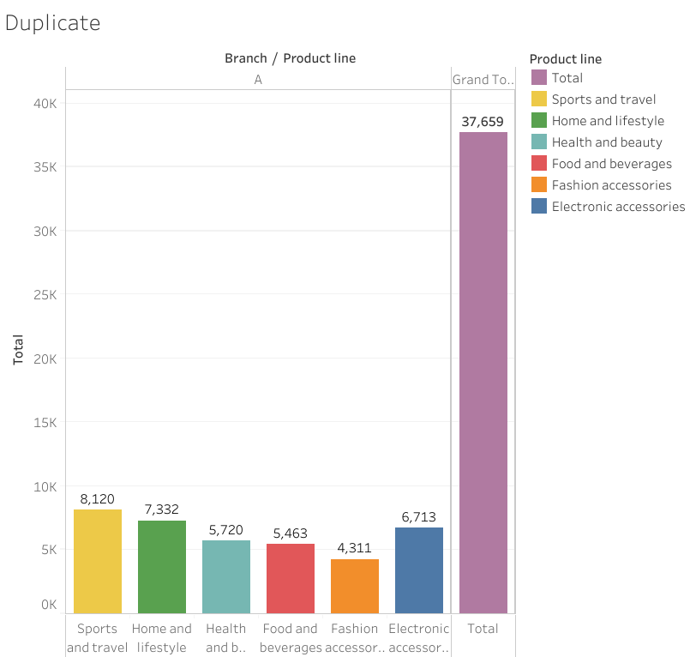

Total Income: 37,659

Highest is Sports and Travel

Lowest is Fashion Accessories

Store-B)

Total Income: 34,597

Highest is Home and Lifestyle

Lowest is Food and Beverages

Store-C)

Total Income: 37,199

Highest is Food Beverages

Lowest is Sports and Travel

All IN ONE:

For store-A, Highest Income came from “Home and Lifestyle (22,417)”

Lowest Income came from “Health and Beauty (12,598)”

For store-B, Highest Income came from “Sports and Travel (19,988)”

Lowest Income came from “Food and Beverages (15,215)”

For store-C, Highest Income came from “Food and Beverages (23,767)”

Lowest Income came from “Home and Lifestyle (13,896)”

**Analysis:**

Checking why Store-A has the highest income from **“Home and Lifestyle”** and Store-C has lowest income from the same product line only.

Comparing attributes of Store-A and Store-C.

**Comparing Unit Price:**

The Unit price for Store A and C are almost the same which are 55.846 and 54.334 respectively.

**Comparing Quantity:**

The total quantity sold by Store-A is 371 and Store-B sold 245 only.

**Morning Time Sales (10 A.M. to 11:59 A.M.)**

**Morning Qty for Store-A is 90.**

**Morning Qty for Store C is 47.**

**Afternoon Time Sales (12 P.M. to 02:00 P.M.)**

**Afternoon (12 P.M. to 2 P.M.) Qty for Store-A is 52.**

**Afternoon (12 P.M. to 2 P.M.) Qty for Store-C is 53.**

**Afternoon Time Sales (02:00 P.M. to 04:00 P.M.)**

**Afternoon Qty for Store-A is 79.**

**Afternoon Qty for Store-C is 34.**

**Evening Time Sales (04:00 P.M. to 06:00 P.M.)**

**Evening Qty for Store-A is 84.**

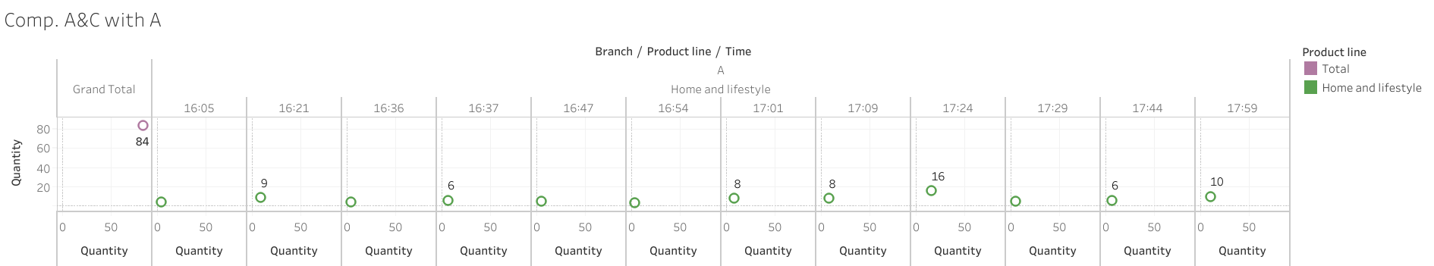

**Evening Qty for Store-C is 65.**

**Evening Time Sales (06:00 P.M. to 09:00 P.M.)**

**Evening Qty for Store-A is 66.**

**Evening Qty for Store-C is 46.**

**Analysis:**

Checking that why Store-B has earned lowest income from “Food and beverages and Store-C has earned more in that product line only. What is the reason?

|  |  |  |  |  |  |  |  |  |  |
| --- | --- | --- | --- | --- | --- | --- | --- | --- | --- |
| Store-B | | | | | Store-C | | | | |
| 10 to 12 | 12 to 2 | 2 to 4 | 4 to 6 | 6 to 9 | 10 to 12 | 12 to 2 | 2 to 4 | 4 to 6 | 6 to 9 |
| 38 | 59 | 89 | 12 | 72 | 74 | 30 | 60 | 46 | 159 |
| 270 products and Income is 15,215 | | | | | 369 products and Income is 23,767 | | | | |

Store-C sold almost double product in first segment (10 to 12) 38 and 74

In second, segment (12 to 2) Store-c sold less than Store-B. 30 and 59 respectively.

In third, Store-B sold 89 and Store-c sold only 60.

Major difference is in last two segments.

Store-B sold 84 in last two segments

**Store-C sold almost 2.5 times than Store-B which is 205.**

**Store-C Graph:**

**Store-B Graph:**

Conclusion: